(Approx. 609 words)

Organize your Apps on your iPhone and iPad
By Jim Cerny, Instructor, Sarasota Technology Users Group, Florida
May 2018 issue, STUGMonitor
www.thestug.org
jimcerny (at) aol.com

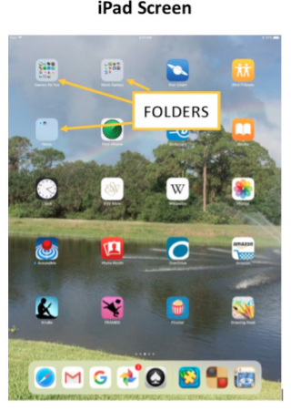
Are you enjoying your iPhone and/or iPad? Quite amazing devices and they offer so much. Going to the App Store and downloading a free app (game, news, entertainment, whatever) can be fun. But what happens when you have several “home screens” on your device with too many apps? Well, you can organize them onto different screens and into “folders” or groups! This is a great way to keep those apps you need handy.

Let’s begin with the basic ways to move your app icons to different home screens. Pick an app, any app, touch your finger to it and hold it there for a moment – and ALL the app icons on your screen will start to wiggle. (Most will have a little “X” in the upper left corner of the icon). Now touch and hold on any app and you can DRAG it with your finger to any other location on that screen or to any other screen by dragging it to the left or right edge. Your device can have several screens of apps. When you are on a screen, look toward the bottom for a row of dots. One dot will be white, and the other gray dots indicate the number of screens you have that contain app icons. The farthest screen to the LEFT is really a control or notification screen and it does not contain app icons. When you have moved the app icon(s) you want to different places, press the “Home” button and that will stop the apps from vibrating and you will be good to go. Remember, you can only move the apps around when you are in “vibrate” mode.

Please practice this a few times and get used to being able to move an app icon to a different screen. You can also move it down onto the bar at the bottom of the screen. This bar, called the “dock” and the apps on it, are always “on top” of any app home screen. The “dock” can only hold a few apps. When you download a new app, it will appear on the first screen that has space for it. Once you find it, you can drag it anywhere you want.

Now here is the helpful fun part – you can put several app icons into a FOLDER. To do this, perform the above, but instead of moving or dragging the app to another place, drag it ON TOP of another app! This will open and create a new folder on that screen which will now contain BOTH apps. Do not let up with your finger until you see that gray folder appear. While the apps are still shaking, touch the text in the rectangle above the folder, and you can change the folder name to anything you want. This is a great way to organize your apps. You can now drag apps into and out of that folder. If you want to change the folder name, touch and hold on any app to get them to vibrate, then go to the folder and touch on the name to change it. And, to really give you lots of room for many apps, each folder can have multiple screens as well! To delete a folder, simply move all the apps out of it. So, by using these simple moves, you can organize many apps into named folders on the screens any way you want. Now that you know how to organize them, you can download more free apps!



